**SQL- ASSIGNMENT 1**

create table CUSTOMER_MAIN(customer_id int Primary key,

cust_name varchar(255) ,

city varchar(255), grade int,

salesman_id int);

INSERT INTO CUSTOMER_MAIN VALUES(3002,'Nick Rimando','New york',100,5001);

INSERT INTO CUSTOMER_MAIN VALUES(3007,'Brad Davis','New York',200,5001);

INSERT INTO CUSTOMER_MAIN VALUES(3005,'Graham Zusi','California',200,5002);

INSERT INTO CUSTOMER_MAIN VALUES(3008,'Julian Green','London',300,5002);

INSERT INTO CUSTOMER_MAIN VALUES(3004,'Fabian Johnson ',' Paris',300,5006);

INSERT INTO CUSTOMER_MAIN VALUES(3009,'Geoff Cameron',' Berlin',100,5003);

INSERT INTO CUSTOMER_MAIN VALUES(3003,'Jozy Altidor',' Moscow',200,5007);

INSERT INTO CUSTOMER_MAIN VALUES(3001,'Brad Guzan',' London',null,5005);

-------------------------------------------------------------------------

Query 1:

select * from CUSTOMER_MAIN;

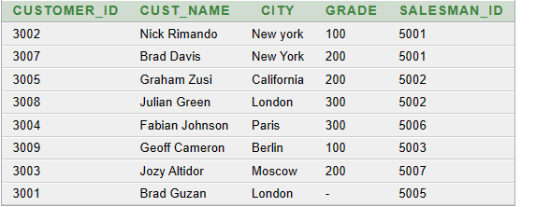

---------------------------------------------------------------------------

Query 2:

select unique city from CUSTOMER_MAIN;

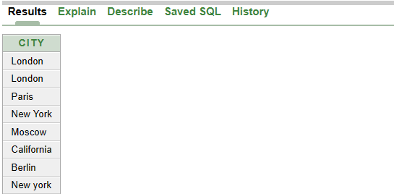

---------------------------------------------------------------------------

Query 3:

select * from customer_main ORDER BY CUST_NAME DESC;

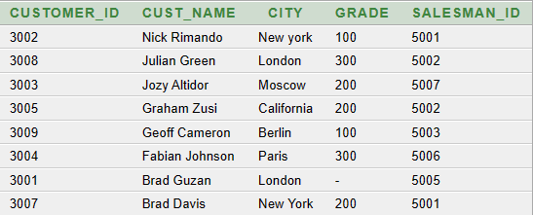

---------------------------------------------------------------------------

Query 4:

SELECT CUSTOMER_ID,CITY FROM CUSTOMER_MAIN where SALESMAN_ID=5002;

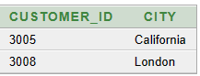

---------------------------------------------------------------------------

Query 5:

SELECT CUSTOMER_ID,CITY FROM CUSTOMER_MAIN where CITY='London';



---------------------------------------------------------------------------

Query 6:

SELECT *FROM CUSTOMER_MAIN ORDER BY CUSTOMER_ID ASC;

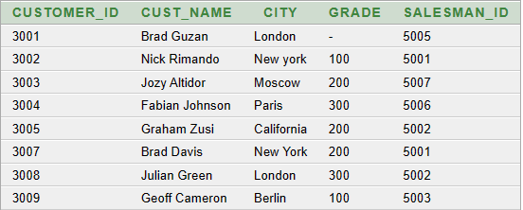

---------------------------------------------------------------------------

Query 7:

SELECT CUST_NAME,SALESMAN_ID FROM CUSTOMER_MAIN where GRADE>200;

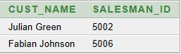

---------------------------------------------------------------------------

Query 8:

SELECT * FROM CUSTOMER_MAIN where CUST_NAME LIKE'B%';

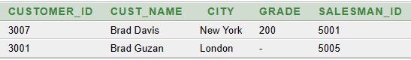

---------------------------------------------------------------------------

Query 9:

SELECT * FROM CUSTOMER_MAIN where SALESMAN_ID != 5006;

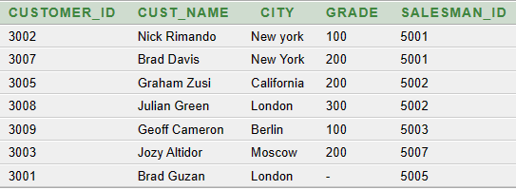

---------------------------------------------------------------------------

Query 10:

SELECT CUST_NAME, CITY, GRADE FROM CUSTOMER_MAIN where CITY ='Paris';



